National University of Computer and Emerging Sciences



Lab Exercise 13

For

Object Oriented Programming Lab

|  |  |
| --- | --- |
| Course Instructor(s) | Dr. Danish |
| Lab Instructor(s) | Mr. Mughees Ismail |
| Semester | Spring 2020 |

**FAST School of Computing**

# Instructions:

1. Make a word document with the naming convention “SECTION_ LAB#_ROLLNO” and put all your source code and snapshots of its output in it. Make sure your word file is formatted properly.
2. Plagiarism is strictly prohibited.
3. Do not discuss solutions with one another.

# Useful links

|  |
| --- |
| **Question#1** |

Write a class String (assuming you already know how string works) and your task is to overload the following operators.

1. Binary + (that concatenates two strings and returns a resultant string)
2. Unary minus ( - ) (that changes the lowercase letter to uppercase and vice versa)
3. >> (that takes the whole string as input including spaces)
4. << (that displays the whole string)
5. Array Subscript Operator ( **[ ]** ) (that returns the character at the given index)
6. == (that returns true or false after strings comparison)
7. != (that returns true if strings are not equal, otherwise returns false)
8. ++ (that right shifts string by a character and places the last character at first index)
9. - - (that left shifts string by a character and places the first character at last index)

|  |
| --- |
| **Question#2** |

***(Polynomial Class)*** Develop class Polynomial. The internal representation of a Polynomial is an array of terms. Each term contains a coefficient and an exponent, e.g., the term 2*x*4 has the coefficient 2 and the exponent 4. Develop a complete class containing proper constructor and destructor functions as well as *set* and *get* functions The class should also provide the following overloaded operator capabilities:

a) Overload the addition operator (+) to add two Polynomials.

b) Overload the subtraction operator (-) to subtract two Polynomials.

c) Overload the assignment operator to assign one Polynomial to another.

d) Overload the multiplication operator (*) to multiply two Polynomials.

e) Overload the addition assignment operator (+=), subtraction assignment operator (-=), and multiplication assignment operator (*=).

**Sample Input:**

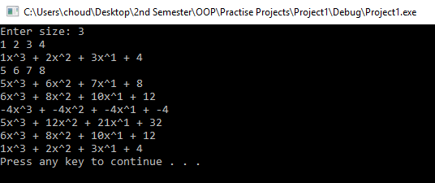

|  |
| --- |
| **Question#3** |

***(Date Class)*** Defining Operator (+=) and Operator (-=) to Add or Subtract Days in the object Given an Integer Input.

**Sample Output:**

